Secondary 2H Name_______________________ Desk _________
Unit 2 Graph Quadratic Functions Given Key Features and Domain and Range
Score _________
Sketch the graph of each function. Label the key features on your graph.

1. x-intercepts: (-3, 0) & (1, 0) 2. x-intercept: (2, 0)
y-intercept: (0, -3) y-intercept: (0, -4)
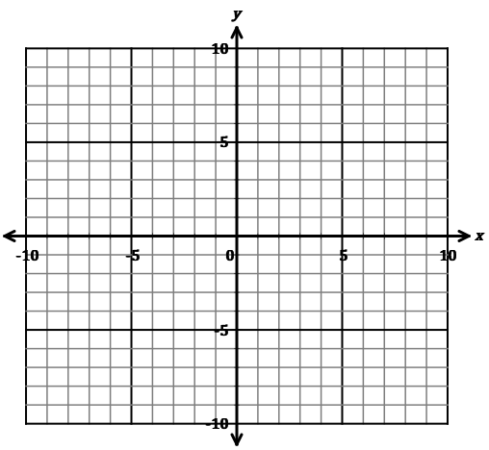
minimum: (-1, -4) maximum: (2, 0)

3. The highest dive in the Olympic Games is from a 10-meter platform. The maximum height is 11.23 meters of a diver is 0.5 seconds after leaving the platform. The diver hits the water at 2 seconds. Sketch a graph of the relationship between time and height for the diver. Label the axes and the key features of the graph.

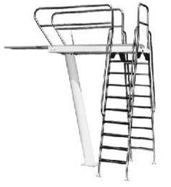

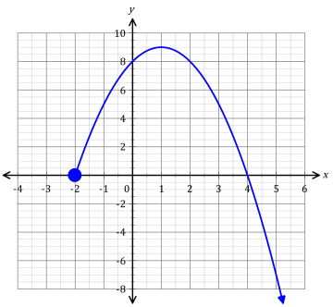
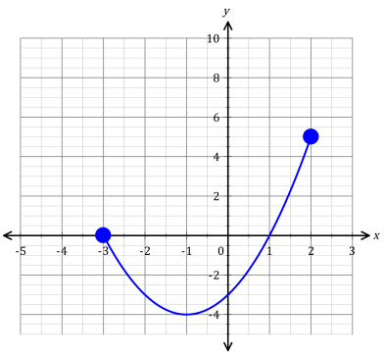
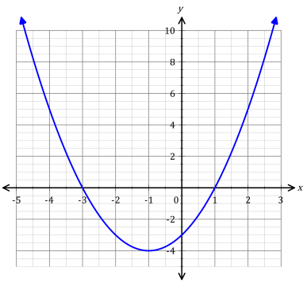
4. 5. 6.

Domain: Domain: Domain:

Range: Range: Range:
Identify the domain and range of each function. Include the unit of measure.
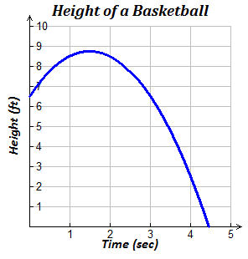
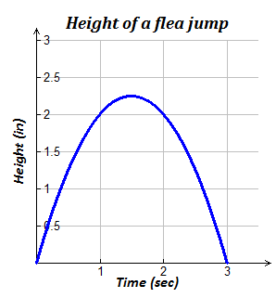
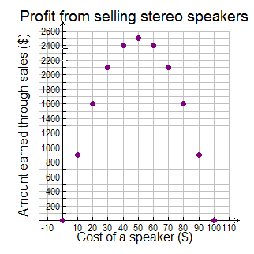
7. 8. 9.

Domain: Domain: Domain:

Range: Range: Range:

10. The graph h(t) represents the height of a tennis ball thrown upward.
h(t)
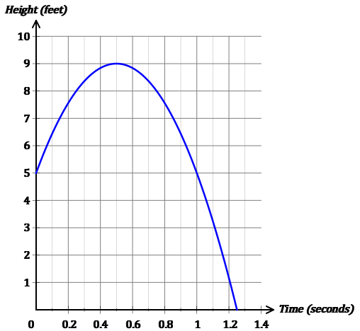
a) What is the domain of the function? Include units in your answer

b) What is the range of the function? Include units in your answer

c) What does the y-intercept represent?

d) Evaluate by reading the graph.
h(0) = h(0.2) h(1) =

e) What does the expression h(0.2) represent?

f) What is the maximum height the tennis ball reaches?

g) When does the tennis ball reach its maximum height?

h) What does the x-intercept represent?

11. The graph h(t) represents the height of a rocket shot up into the sky.
h(t)
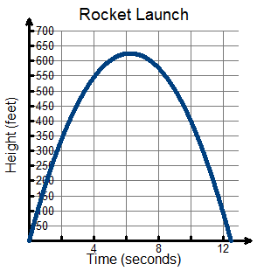
a) What is the domain of the function? Include units in your answer

Write a sentence describing the meaning of the domain for h(t).

b) What is the range of the function? Include units in your answer

Write a sentence describing the meaning of the range for h(t).

c) What does the y-intercept represent?

d) Estimate the height of the rocket at 2 seconds.

e) Estimate the height of the rocket at 8 seconds.

Given the equation of the graph is
f) Evaluate function for the following values.
Show your work!
h(0) = h(8) =

i) Estimate the times (in seconds) that the rocket is at a height of 450 feet. (Hint: there are two answers)

j) What does the x-intercept represent?

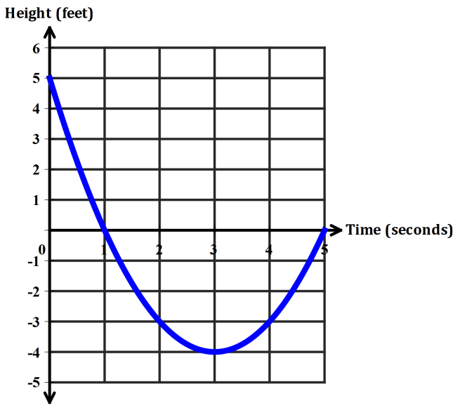
12. The graph represents the height of an air-filled ball thrown in a swimming pool.
a) What is the domain of the function? Include units in your answer.

b) What is the range of the function? Include units in your answer.

c) What does the y-intercept represent?

Given the equation of the graph is
d) Evaluate function for the following values.
Show your work!
h(0) = h(2) =

e) Do the values you calculated in part d match with the values on the graph?

f) Determine the minimum height of the ball.

g) Determine how long it takes the ball to reach its minimum height.

h) Estimate the times (in seconds) that the ball is at a height of -2 feet. (Hint: there are two answers)

i) What does the x-intercept represent?

