Secondary 2H Name_______________________ Desk _________
Unit 1 Finding Key Points on the Graph
Score _________
Find the x- and y-intercept(s) of each table, equation or graph.
x | -3 | -2 | -1 | 0 | 1 | 2 | 3 | 4
y | 10 | 4 | 0 | -2 | -2 | 0 | 4 | 10

x-intercept(s): ________________________ y-intercept: _________________________

1.

2. y = 1 – x² 3. $f\left(x\right)=x^{2}-9$ 4. y = x² – 5x + 6
**HINT: Use a table

x-intercept:
y-intercept:
x-intercepts:
y-intercept:

x-intercepts:
y-intercept:

.

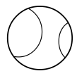
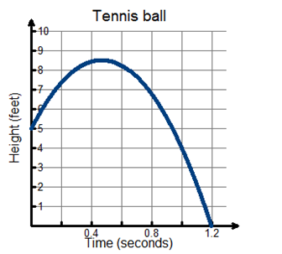
5. The graph represents the flight of a tennis ball.
a. What does the x-intercept on the graph represent?

b. What does the y-intercept on the graph represent?

6. Rocket Launch
Rocket Launch
a. What does the x-intercept on the graph represent?
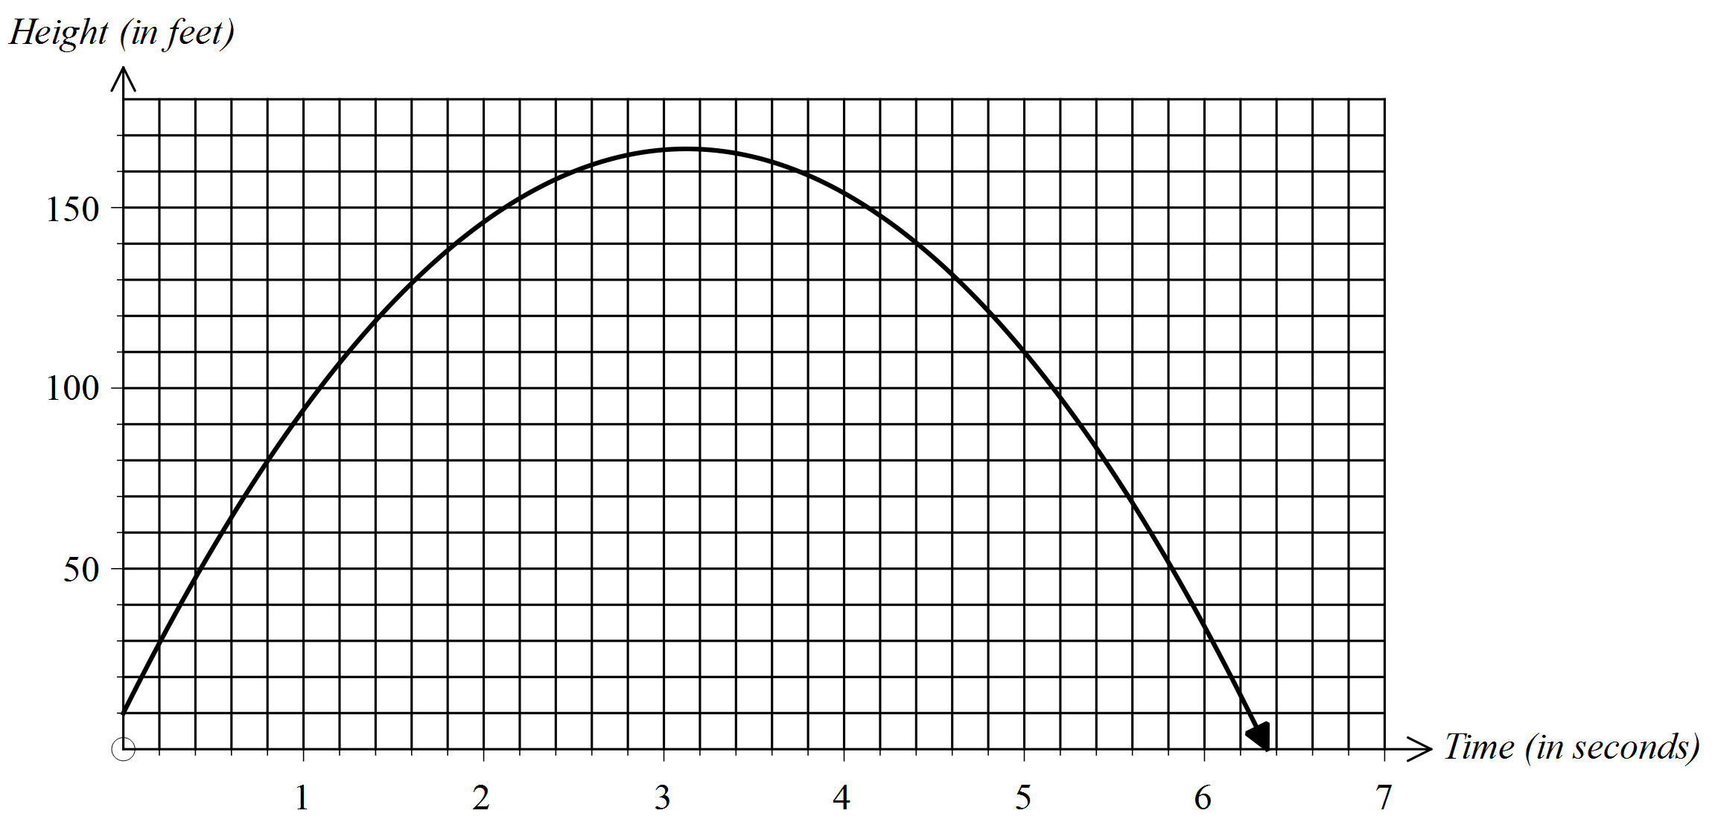

Height (feet)

b. What does the y-intercept on the graph represent?



Time (seconds)

Find the vertex. Determine if the vertex is a maximum or minimum point and whether the graph is concave up or concave down.
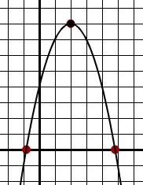
7. 8. Kjfk 9.
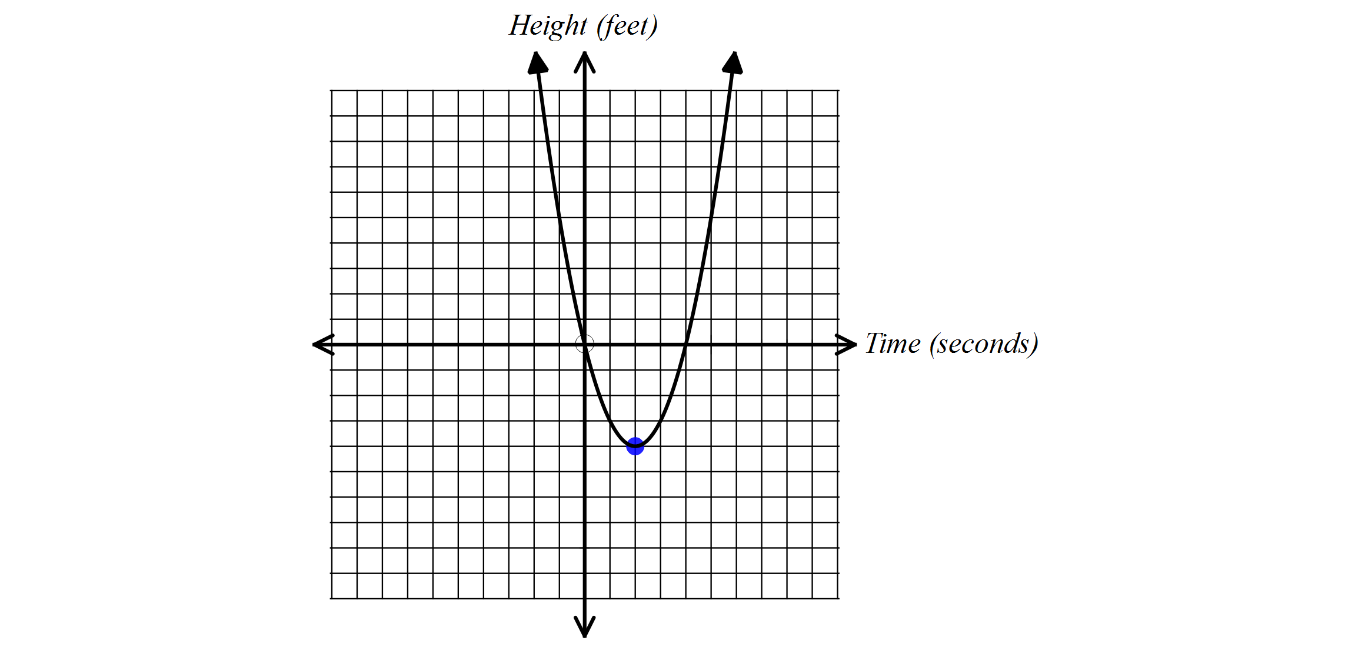
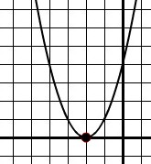

Vertex: Vertex: Vertex:
Maximum or Minimum Maximum or Minimum Maximum or Minimum

Concave Up/Concave Down Concave Up/Concave Down Concave Up/Concave Down
Complete the table of values for each function using a graphing calculator. Determine if the vertex is a maximum or minimum point and find the vertex.
$10. f\left(x\right)=x^{2}+2x-5$ $11. f\left(x\right)=6x^{2}+11x-1$ 12. $g\left(x\right)=-\left(x-1\right)$²
x | g (x)
-3
-2
-1
0
1
2

x | f (x)
-2
-1
0
1
2
3

x | f (x)
-3
-2
-1
0
1
2

Maximum or Minimum Maximum or Minimum Maximum or Minimum

Vertex: Vertex: Vertex:
13. Draw a quadratic graph with 14. Draw a quadratic graph with
a maximum point at (2, 4). a minimum point at (2, 4).
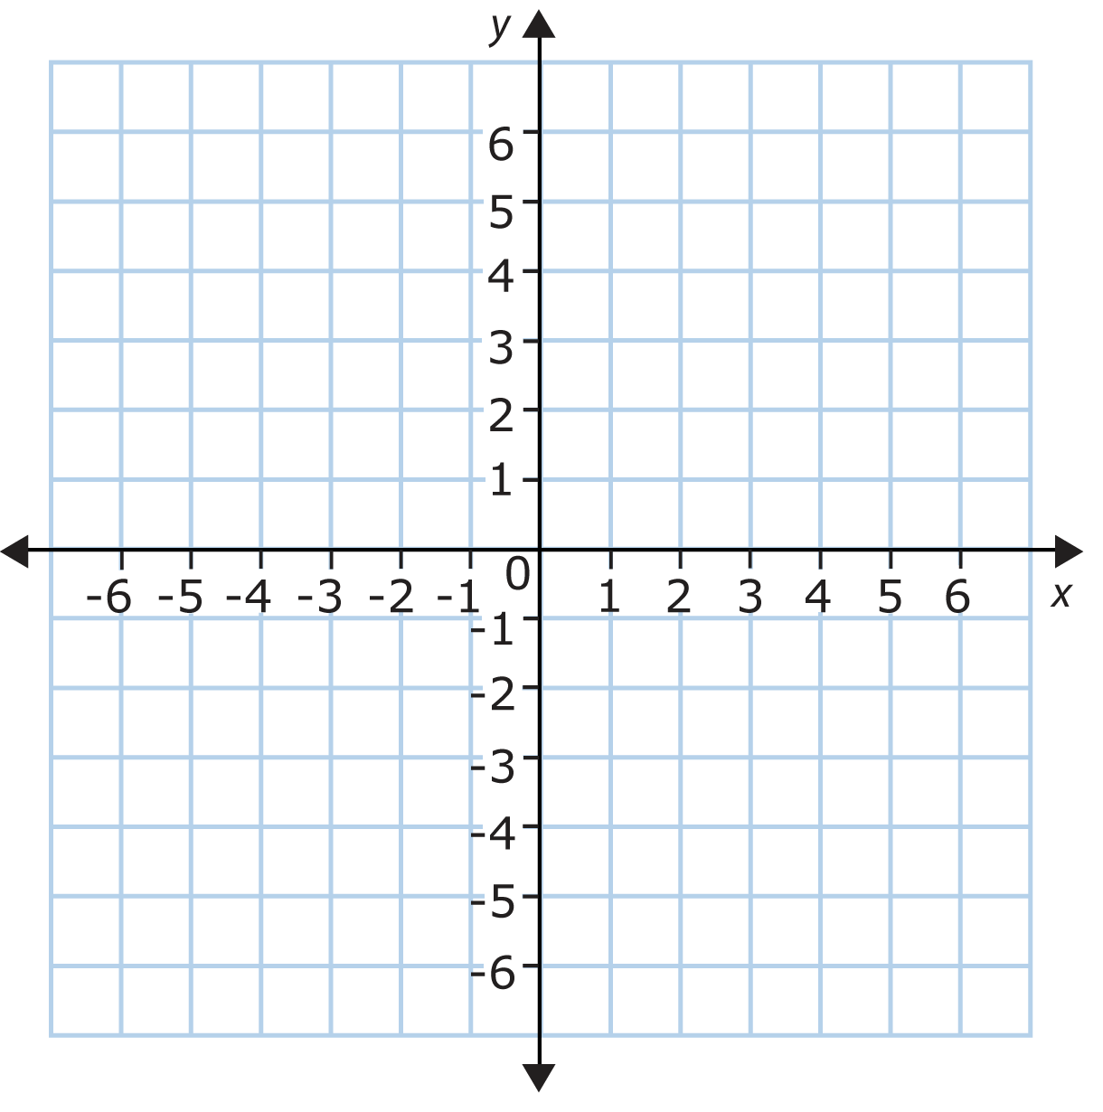

15. Suppose a frog jumps straight up in the air. The table below shows how the frog’s height in inches after t seconds changes as it jumps and returns to the ground.
t | h (t)
0 | 0
1 | 48
2 | 64
3 | 48
4 | 0


a. Describe how the frog’s height changes over the four-second time period.

b. Describe what the graph of the data would look like. (answers will vary)

c. What is the maximum height the frog reaches?
d. When does the frog reach its maximum height?
e. When is the frog at approximately 58 inches? (Hint: There are two answers).

Find the vertex and the axis of symmetry.
16. 17. 18.
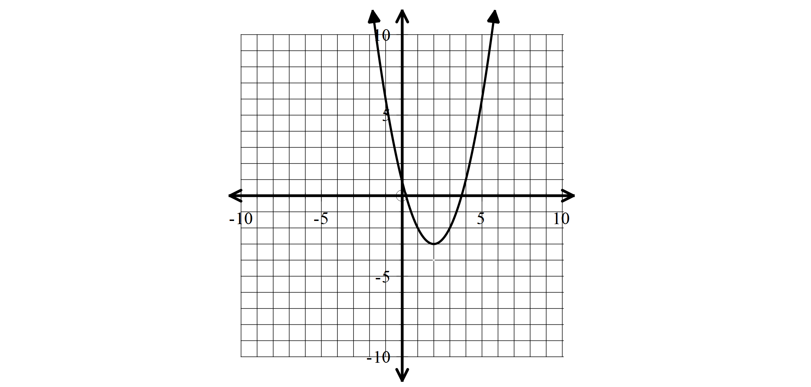
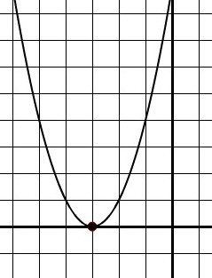

Vertex: Vertex: Vertex:

Axis of Symmetry: Axis of Symmetry: Axis of Symmetry:

x | f (x)
-3 | -16
-2 | -9
-1 | -4
0 | -1
1 | 0
2 | -1
3 | -4

x | y
-1 | 0
0 | -3
1 | -4
2 | -3
3 | 0
4 | 5
5 | 12

x | f (x)
-1 | 15
0 | 8
1 | 3
2 | 0
3 | -1
4 | 0
5 | 3

19. 20. 21.

Vertex: Vertex: Vertex:

Axis of Symmetry: Axis of Symmetry: Axis of Symmetry:
22. y = -(x – 1)² + 4 23. y = (x – 5)² – 4 24. y = (x + 1)² – 3

Vertex: Vertex: Vertex:

Axis of Symmetry: Axis of Symmetry: Axis of Symmetry:

Answer the following questions in complete sentences.
25. Explain how the vertex helps you determine the axis of symmetry.

26. Explain how to identify the vertex of a parabola given a table of values.

27. Explain how to identify the axis of symmetry given a parabola in vertex form.

28. Is it possible to write the equation of a parabola if given only the axis of symmetry? Why or why not?

